Louise Arbour Secondary School 2012-2013

**Welcome to Grade 12 Physics (SPH4U)! Teacher: Ms. Ryan**

******Personal Profile: Please write a short personal profile or reflection telling me a bit about yourself! Important points to include are:**

●activities you pursued this summer

●hobbies, activities, extra-curricular plans, job commitments

●your reason for taking physics

●potential career paths or interests

●academic strengths and weaknesses and your strategies for success

[](http://www.google.ca/imgres?q=smiley+face+icons&um=1&hl=en&sa=N&biw=1140&bih=517&tbm=isch&tbnid=7Pw6mT5uuZlQkM:&imgrefurl=http://www.creativepro.com/node/58744&docid=ugrdN1MsOYIMkM&w=300&h=315&ei=rR1lTrD4M6bw0gGOg_mVCg&zoom=1) ●topics in physics you’re most interested in-is there any area in current physics research that you’d like to explore?

●any other information you’d like to share!

**Homework: Fermi Question Challenge**

**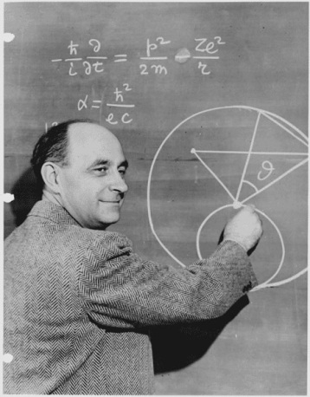***Fermi questions are named after Italian-born physicist Enrico Fermi. Fermi was legendary for being able to quickly solve problems in which the variables were not well defined. His approach involved estimating unknown quantities and then proceeding through calculations using these estimates.*

*In a Fermi question, the goal is to make reasonable assumptions about a situation to arrive at an answer which is within an* ***"order of magnitude"*** *of the actual answer. In solving a Fermi question, the thought process is much more important than the answer obtained!*

*Get your thinking caps on and make sure to show your analysis and assumptions to answer the following questions*

**Question 1: How many water balloons would fill our classroom?**

**Question 2: How many dentists are there in the city of Toronto (current population 2.5 million)?**